[](https://www.comsol.com/)

Ex2 DuongThuPhuong 22BI13362

Report date

Nov 5, 2023, 7:09:56 PM

Contents

1. Global Definitions

1.1. Parameters

2. Component 1

2.1. Definitions

2.2. Geometry 1

2.3. Materials

2.4. Laplace Equation

2.5. Turbulent Flow, SST

2.6. Mesh 1

3. Study 1

3.1. Stationary

4. Study 2

4.1. Wall Distance Initialization

4.2. Stationary

5. Results

5.1. Datasets

5.2. Derived Values

5.3. Tables

5.4. Plot Groups

1. Global Definitions

|  |  |
| --- | --- |
| Date | Nov 1, 2023, 4:45:52 PM |

Global settings

|  |  |
| --- | --- |
| Name | Ex2 DuongThuPhuong 22BI13362.mph |
| Path | C:\Users\WINDOWS\Downloads\Ex2_DuongThuPhuong_22BI13362.mph |
| Version | COMSOL Multiphysics 6.0 (Build: 318) |

Used products

|  |
| --- |
| CFD Module |
| Design Module |
| COMSOL Multiphysics |
| CAD Import Module |

Computer information

|  |  |
| --- | --- |
| CPU | Intel(R) Core(TM) i5-8250U CPU @ 1.60GHz, 4 cores |
| Operating system | Windows 10 |

* 1. Parameters

Parameters 1

| **Name** | **Expression** | **Value** | **Description** |
| --- | --- | --- | --- |
| U_inf | 50[m*s^ - 1] | 50 m/s | Free-stream velocity |
| rho_inf | 1.2043[kg*m^ - 3] | 1.2043 kg/m³ | Free-stream density |
| mu_inf | 1.81397e-5[kg*m^ - 1*s^ - 1] | 1.814E−5 kg/(m·s) | Free-stream dynamic viscosity |
| L | 180[m] | 180 m | Domain reference length |
| c | 1.8[m] | 1.8 m | Chord length |
| k_inf | 0.1*mu_inf*U_inf/(rho_inf*L) | 4.184E−7 m²/s² | Free-stream turbulent kinetic energy |
| om_inf | 10*U_inf/L | 2.7778 1/s | Free-stream specific dissipation rate |
| alpha | 0 | 0 | Angle of attack |

1. Component 1
   1. Definitions
      1. Coordinate Systems

#### Boundary System 1

|  |  |
| --- | --- |
| Coordinate system type | Boundary system |
| Tag | sys1 |

Coordinate names

| **First** | **Second** | **Third** |
| --- | --- | --- |
| t1 | n | to |

* 1. Geometry 1

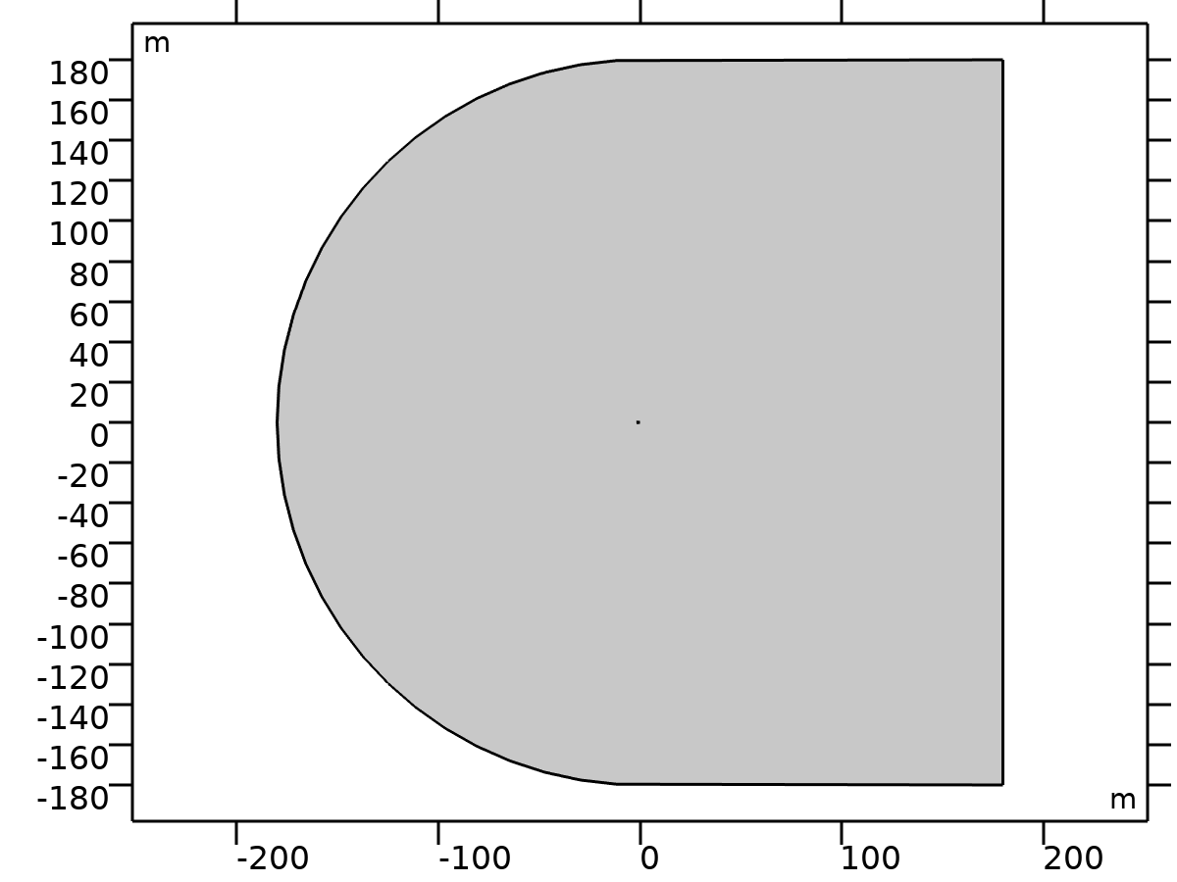

Geometry 1

Units

|  |  |
| --- | --- |
| Length unit | m |
| Angular unit | deg |

* 1. Materials
     1. Air

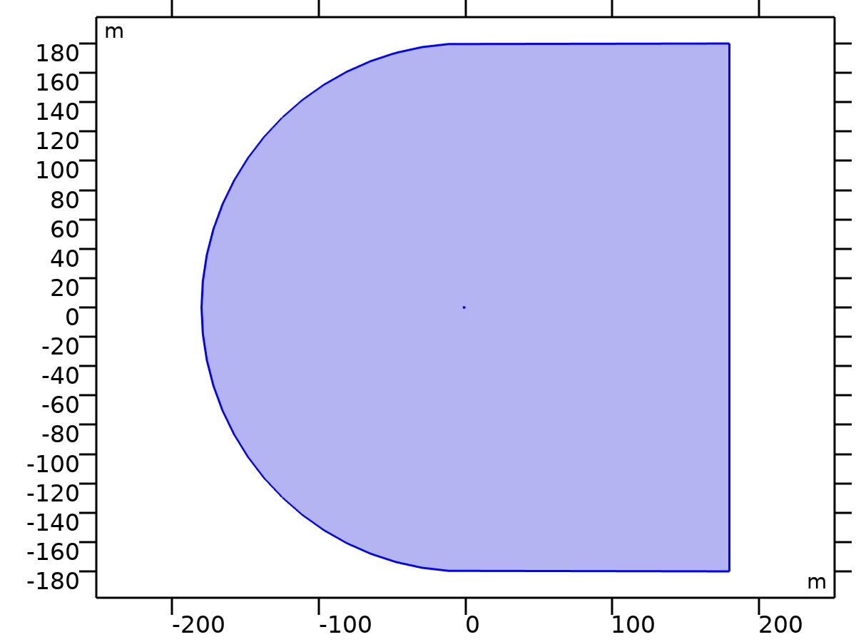

Air

Selection

|  |  |
| --- | --- |
| Geometric entity level | Domain |
| Selection | Geometry geom1: Dimension 2: All domains |

* 1. Laplace Equation



Laplace Equation

Features

| **Name** | **Level** |
| --- | --- |
| Laplace Equation 1 | Domain |
| Zero Flux 1 | Boundary |
| Initial Values 1 | Domain |
| Dirichlet Boundary Condition 1 | Boundary |
| Flux/Source 1 | Boundary |

* 1. Turbulent Flow, SST



Turbulent Flow, SST

Equations

















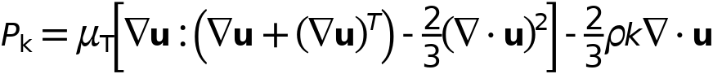



Features

| **Name** | **Level** |
| --- | --- |
| Fluid Properties 1 | Domain |
| Initial Values 1 | Domain |
| Wall 1 | Boundary |
| Inlet 1 | Boundary |
| Open Boundary 1 | Boundary |

* 1. Mesh 1

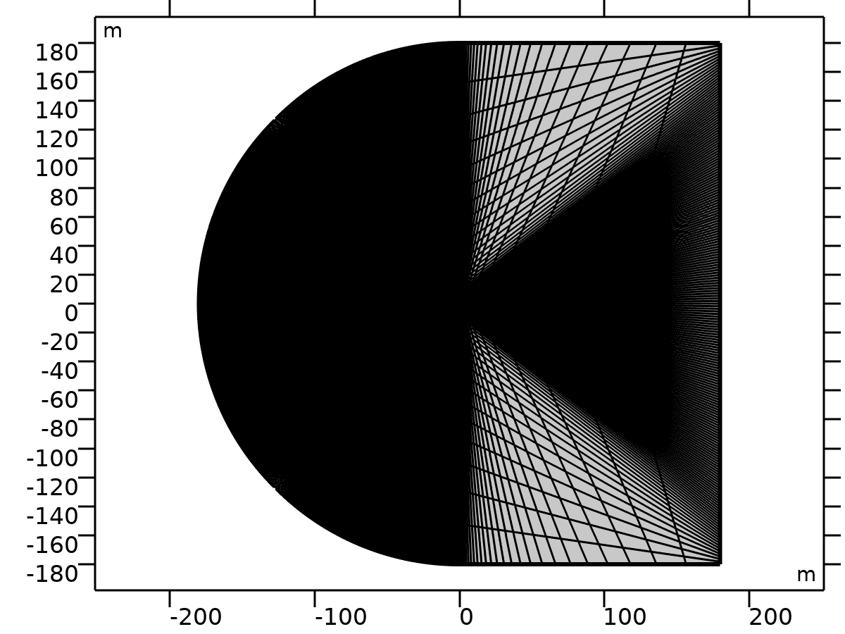

Mesh 1

1. Study 1

Computation information

|  |  |
| --- | --- |
| Computation time | 12 s |

* 1. Stationary

Study settings

| **Description** | **Value** |
| --- | --- |
| Include geometric nonlinearity | Off |

Physics and variables selection

| **Physics interface** | **Discretization** |
| --- | --- |
| Laplace Equation (lpeq) | physics |

Mesh selection

| **Geometry** | **Mesh** |
| --- | --- |
| Geometry 1 (geom1) | mesh1 |

1. Study 2

Computation information

|  |  |
| --- | --- |
| Computation time | 1 h 23 min 28 s |

* 1. Wall Distance Initialization

Study settings

| **Description** | **Value** |
| --- | --- |
| Include geometric nonlinearity | Off |

Values of dependent variables

| **Description** | **Value** |
| --- | --- |
| Settings | User controlled |
| Study | Study 1 |

Physics and variables selection

| **Physics interface** | **Discretization** |
| --- | --- |
| Turbulent Flow, SST (spf) | physics |

Mesh selection

| **Geometry** | **Mesh** |
| --- | --- |
| Geometry 1 (geom1) | mesh1 |

* 1. Stationary

Study settings

| **Description** | **Value** |
| --- | --- |
| Include geometric nonlinearity | Off |

Values of dependent variables

| **Description** | **Value** |
| --- | --- |
| Settings | User controlled |
| Study | Study 1 |

Study extensions

| **Description** | **Value** |
| --- | --- |
| Auxiliary sweep | On |
| Sweep type | Specified combinations |

Parameters

| **Parameter name** | **Parameter value list** | **Parameter unit** |
| --- | --- | --- |
| alpha (Angle of attack) | 0,2,4,6,8,10,12,14 |  |

Physics and variables selection

| **Physics interface** | **Discretization** |
| --- | --- |
| Turbulent Flow, SST (spf) | physics |

Mesh selection

| **Geometry** | **Mesh** |
| --- | --- |
| Geometry 1 (geom1) | mesh1 |

* + 1. Study extensions

Study extensions

| **Description** | **Value** |
| --- | --- |
| Auxiliary sweep | On |
| Sweep type | Specified combinations |

Parameters

| **Parameter name** | **Parameter value list** | **Parameter unit** |
| --- | --- | --- |
| alpha (Angle of attack) | 0,2,4,6,8,10,12,14 |  |

1. Results
   1. Datasets
      1. Study 1/Solution 1

Solution

| **Description** | **Value** |
| --- | --- |
| Solution | Solution 1 |
| Component | Component 1 (comp1) |

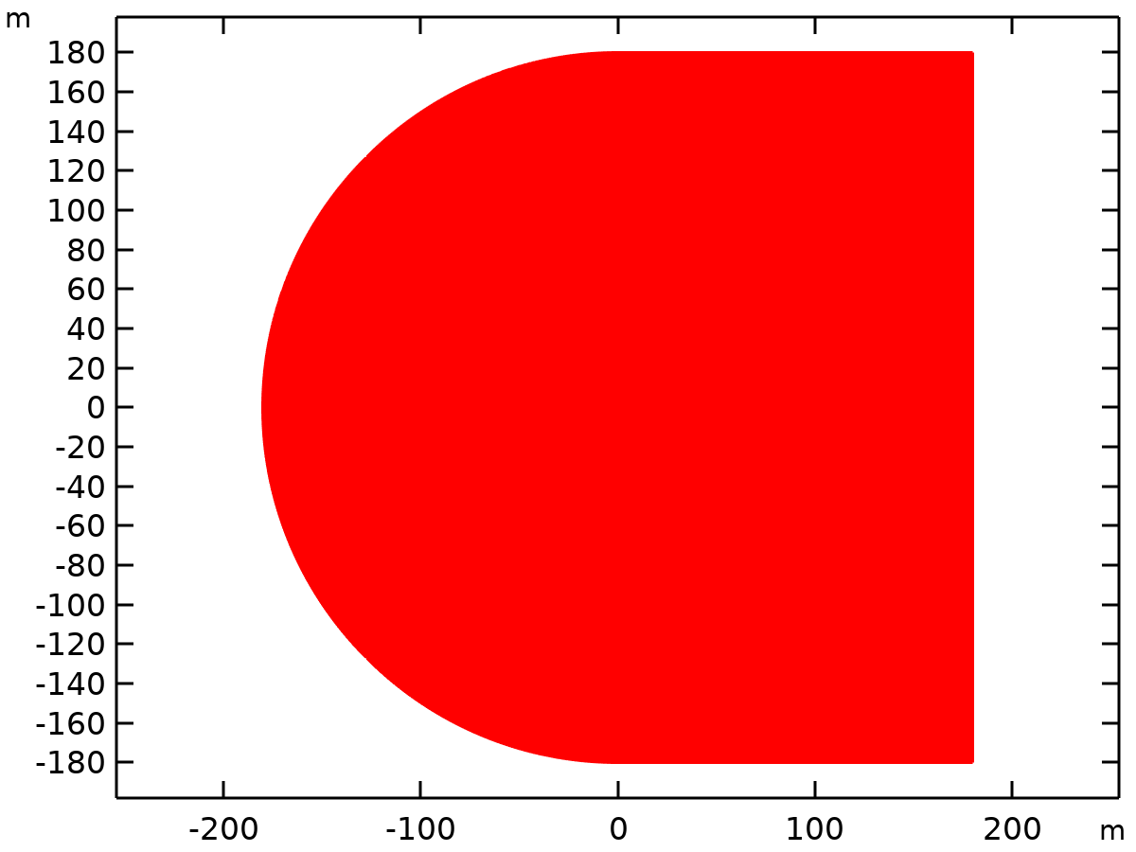

Dataset: Study 1/Solution 1

* + 1. Study 2/Solution 2

Solution

| **Description** | **Value** |
| --- | --- |
| Solution | Solution 2 |
| Component | Component 1 (comp1) |



Dataset: Study 2/Solution 2

* + 1. Study 2/Solution Store 1

Solution

| **Description** | **Value** |
| --- | --- |
| Solution | Solution Store 1 |
| Component | Component 1 (comp1) |



Dataset: Study 2/Solution Store 1

* + 1. Exterior Walls

Data

| **Description** | **Value** |
| --- | --- |
| Dataset | Study 2/Solution 2 |

* 1. Derived Values
     1. Line Integration 1

Output

|  |  |
| --- | --- |
| Evaluated in | Table 1 |

Data

| **Description** | **Value** |
| --- | --- |
| Dataset | Study 2/Solution 2 |

Expressions

| **Expression** | **Unit** | **Description** |
| --- | --- | --- |
| phi | m^3/s | Dependent variable phi |
| p/(1/2*rho_inf*U_inf^2)/c*(spf.nymesh*cos(alpha*pi/180)-spf.nxmesh*sin(alpha*pi/180)) | 1 |  |

Integration settings

| **Description** | **Value** |
| --- | --- |
| Integration order | 4 |

* 1. Tables
     1. Table 1

Line Integration 1

| **alpha** | **Dependent variable phi (m^3/s)** | **p/(1/2*rho_inf*U_inf^2)/c*(spf.nymesh*cos(alpha*pi/180)-spf.nxmesh*sin(alpha*pi/180)) (1)** |
| --- | --- | --- |
| 0.0000 | 0.0000 | 3.8335E-9 |
| 2.0000 | 0.0000 | 0.22115 |
| 4.0000 | 0.0000 | 0.44100 |
| 6.0000 | 0.0000 | 0.65746 |
| 8.0000 | 0.0000 | 0.86822 |
| 10.000 | 0.0000 | 1.0699 |
| 12.000 | 0.0000 | 1.2573 |
| 14.000 | 0.0000 | 1.4203 |

* + 1. Table 2

| **Column 1** | **Column 2** |
| --- | --- |
| -0.050000 | -0.012600 |
| 2.0500 | 0.21250 |
| 4.0400 | 0.43160 |
| 6.0900 | 0.65460 |
| 8.3000 | 0.88730 |
| 10.120 | 1.0707 |
| 11.130 | 1.1685 |
| 12.120 | 1.2605 |
| 13.080 | 1.3455 |
| 14.220 | 1.4365 |
| 15.260 | 1.5129 |
| 16.300 | 1.5739 |
| 17.130 | 1.6116 |
| 18.020 | 0.99670 |
| 19.080 | 1.1358 |

* + 1. Table 3

| **Column 1** | **Column 2** |
| --- | --- |
| 0.0000 | 3.6642 |
| 0.0021834 | 5.0438 |
| 0.0087336 | 5.2407 |
| 0.013100 | 4.6713 |
| 0.017467 | 4.3208 |
| 0.048035 | 2.7435 |
| 0.074236 | 2.2612 |
| 0.098253 | 1.9541 |
| 0.12445 | 1.7345 |
| 0.14629 | 1.5588 |
| 0.17686 | 1.3611 |
| 0.28821 | 1.0083 |
| 0.32096 | 0.94188 |
| 0.38428 | 0.78721 |
| 0.44760 | 0.65443 |
| 0.51528 | 0.54346 |
| 0.57642 | 0.43263 |
| 0.63756 | 0.34370 |
| 0.70087 | 0.25473 |
| 0.76638 | 0.16570 |
| 0.83188 | 0.098572 |
| 0.89301 | 0.0096421 |
| 0.95852 | -0.079384 |
| 1.0000 | -0.12409 |

* 1. Plot Groups
     1. Potential Flow

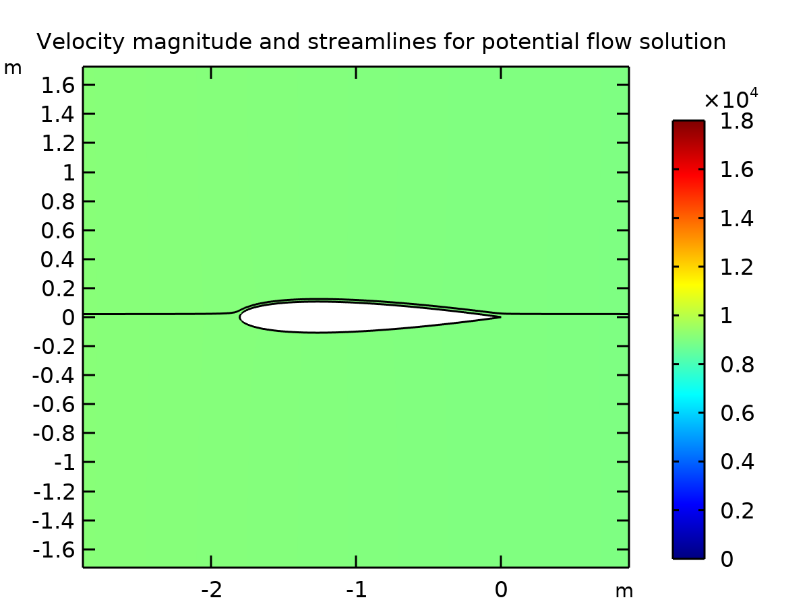

Velocity magnitude and streamlines for potential flow solution

* + 1. Velocity (spf)

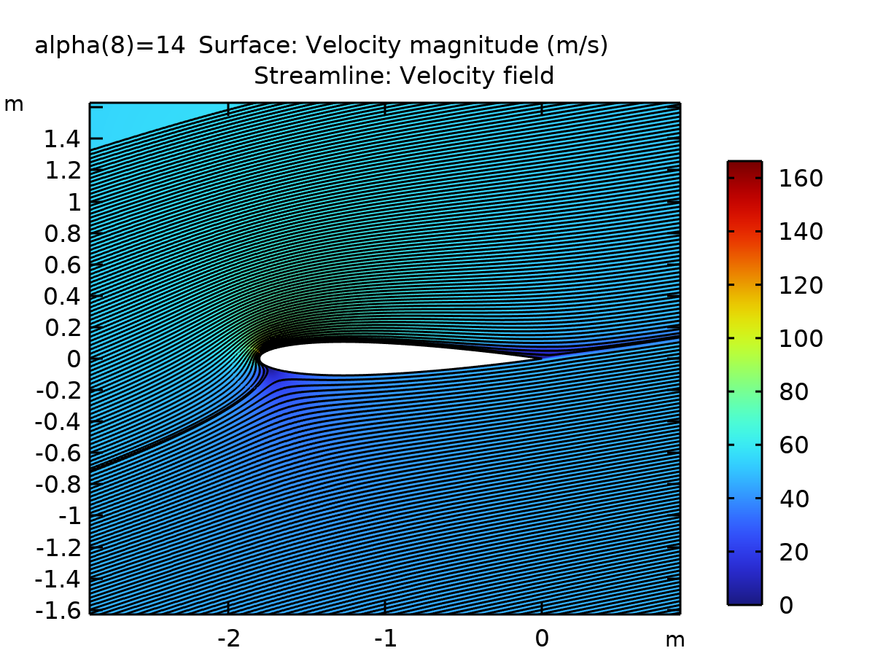

Surface: Velocity magnitude (m/s) Streamline: Velocity field

* + 1. Pressure (spf)

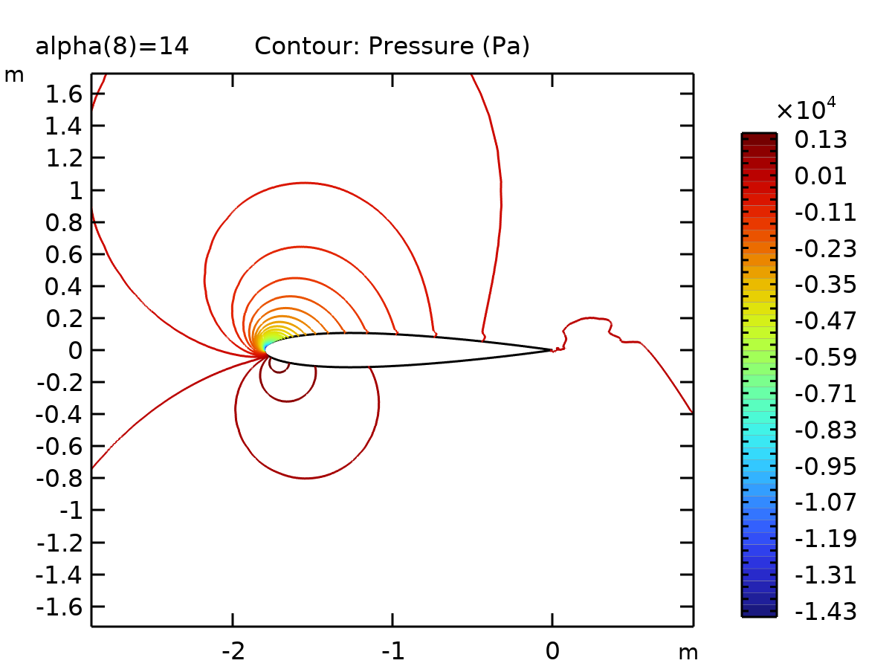

Contour: Pressure (Pa)

* + 1. Wall Resolution (spf)

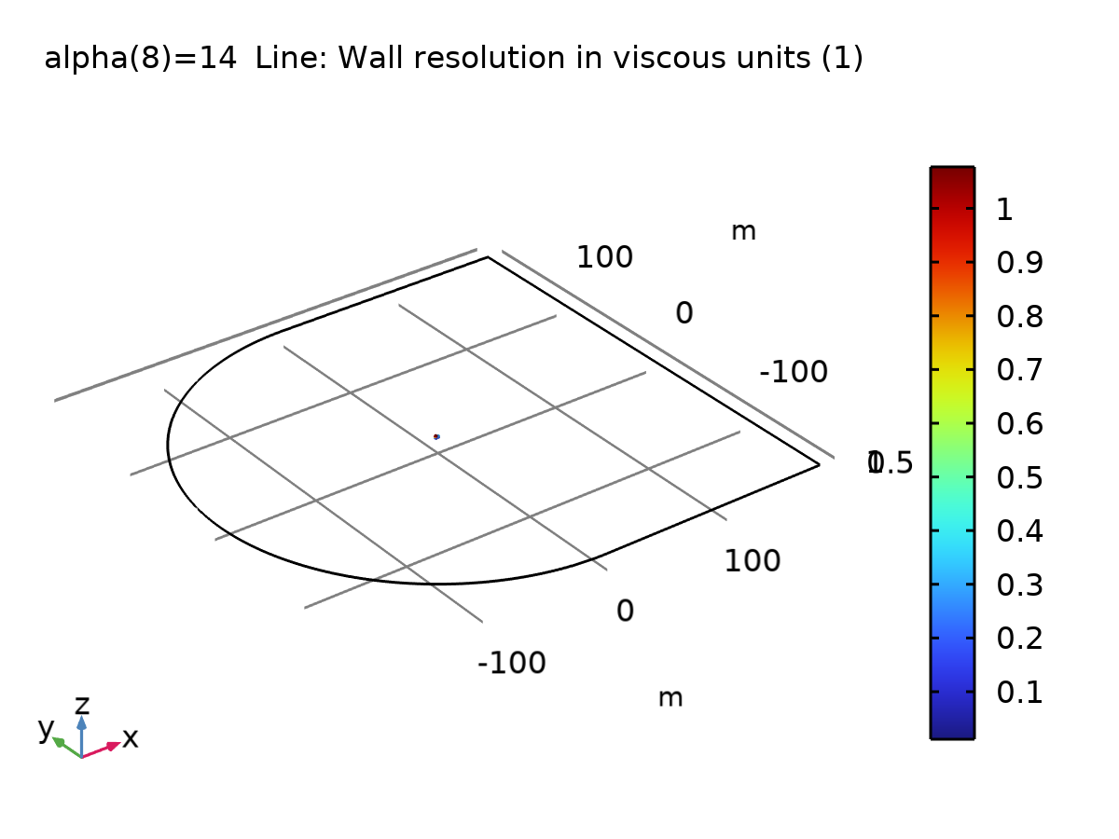

Line: Wall resolution in viscous units (1)

* + 1. 1D Plot Group 5

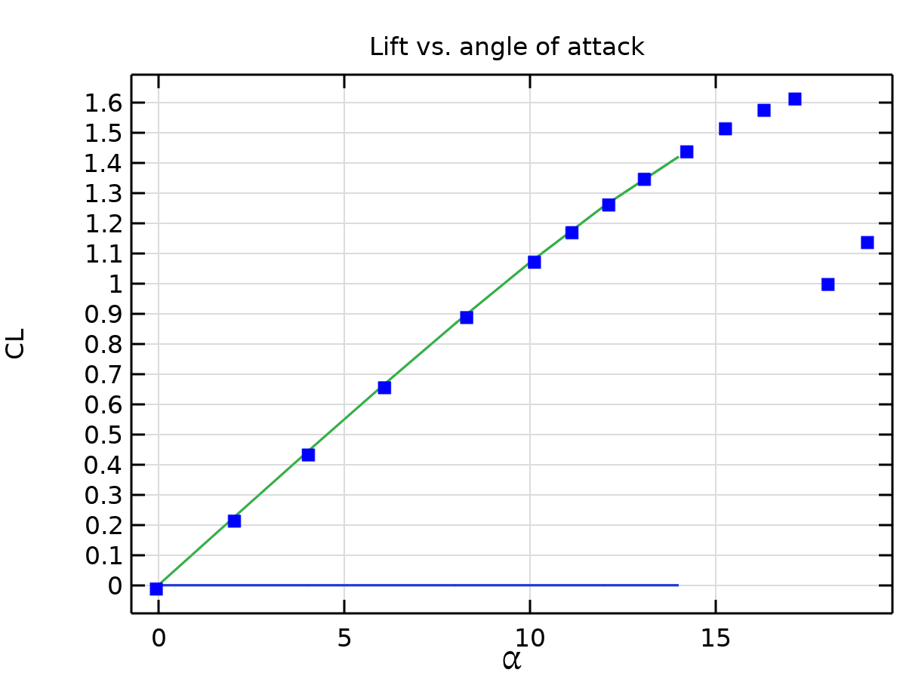

Lift vs. angle of attack

* + 1. 1D Plot Group 6

